Template case study
  - WP n.2 – T2.7.1
Elga Contardi - EGInA

Template case study – [Title of the project]

Overall

- Short project summary: ((if written, maximum 500 words)
MuévetEX consists of the creation of an application that offers rides to neighbors heading to the same destination, allowing them to share expenses and travel in a safe, easy, and efficient way. With this accessible, shared, and sustainable tool, the Sierra la Calera team seeks to connect rural areas of Extremadura and break down communication barriers between towns caused, among other reasons, by the lack of public transportation. In addition, drivers will receive benefits as part of their service, such as discounts in local shops, bars, and municipal services in the area.
- Including logos or icons for visual navigation (e.g. SDG icons, VET symbols, ENNEPlus visual identity and EU visibility requirements).
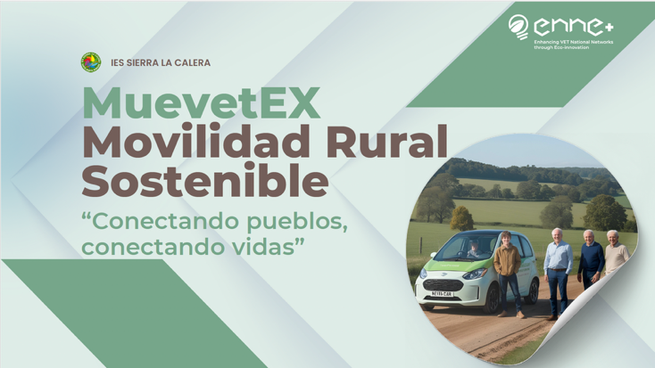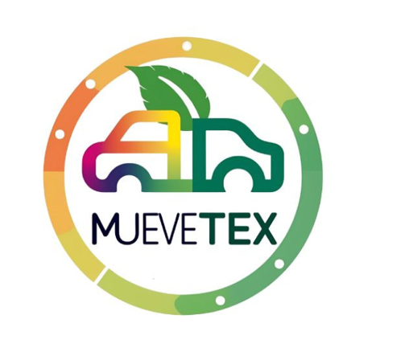
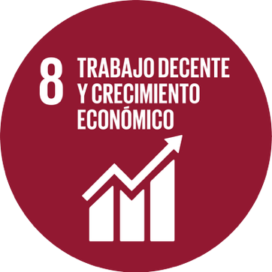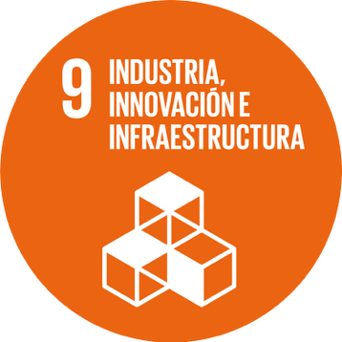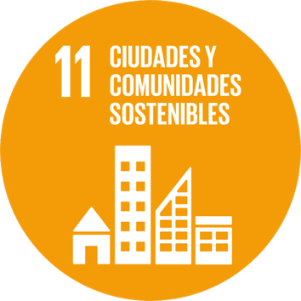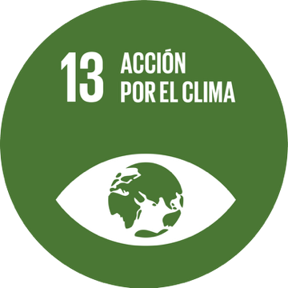

Context

- Country: Spain
- Full Name of the VET provider: IES Sierra La Calera
- Persons involved: clarify the quantity and quality of students involved, teachers involved and societal case provider.
24 persons have been involved in the project.
2 teachers and 21 students from VET study of Administration and Management.
1 representant for Education, Training, Culture and Employment (Santa Marta de los Barros City Council).
- Relevant Challenge Based Learning Scenarios (CBLSs): (include all the relevant CBLS your project is tackling).
Sustainable Transport
List of the 10 CBLSs
Sustainable transport | Protecting Biodiversity in Renewable Energy Power Plants
Green Construction | Circular Economy
Renewable energy | Water Scarcity
Environmental awareness | Water and Human Health
Short Food Supply Chain | Improving Water Quality

Developed Idea

- Title and short description of the idea: (if written, maximum 500 words)
MuevetEX
MuévetEX consists of the creation of an application that offers rides to neighbors heading to the same destination, allowing them to share expenses and travel in a safe, easy, and efficient way. With this accessible, shared, and sustainable tool, the Sierra la Calera team seeks to connect rural areas of Extremadura and break down communication barriers between towns caused, among other reasons, by the lack of public transportation. In addition, drivers will receive benefits as part of their service, such as discounts in local shops, bars, and municipal services in the area.
- Start and end date of the prototyping process: 01/09/2024 – 30/06/2025
- Main objective of the initiative: This project aims to tackle the lack of transportation in rural areas and their connectivity.
- Local Community Impact: (if written, maximum 500 words)
MuévetEX was created to respond to a real and urgent problem: the lack of transportation and connectivity in rural areas such as Tierra de Barros. Many residents, including workers, young people, and the elderly, face daily difficulties in accessing essential services like medical appointments, workplaces, or family visits.
The project addresses this issue through an accessible and sustainable mobile application that connects neighbors traveling to the same destination. By sharing rides and expenses, users can move safely, easily, and efficiently while reducing costs and environmental impact.
MuévetEX not only improves mobility but also strengthens community ties by fostering cooperation and solidarity among residents. It helps reduce social isolation and enhances inclusion in rural territories often neglected by traditional transport networks.
Additionally, the project supports local economies by offering drivers incentives such as discounts in local shops, bars, and municipal services, promoting both participation and local business growth.
Overall, MuévetEX contributes to sustainable rural development, promotes shared responsibility, and aligns with European objectives for greener, more connected communities. It is a practical, community-driven solution to one of the most persistent challenges in rural Extremadura: the lack of mobility and social connection.
- Social Relevance and Innovation: (if written, maximum 500 words)
MuévetEX is socially relevant because it directly tackles rural isolation and the lack of mobility in areas like Tierra de Barros, enabling equal access to services and opportunities. Its innovation lies in creating a shared, digital, and sustainable mobility network that connects neighbors with similar destinations. By combining technology, community engagement, and environmental responsibility, MuévetEX transforms transportation into a collaborative, eco-friendly solution that strengthens social cohesion and supports local development in rural Extremadura.
- Transferability and Openness: (if written, maximum 500 words)
MuévetEX is highly transferable and adaptable to other rural regions facing similar mobility challenges. Its digital platform can be easily replicated with minimal infrastructure, adjusting routes, incentives, and partnerships to local needs. The project’s open, community-based approach encourages collaboration with municipalities, local businesses, and citizens, promoting shared ownership and long-term sustainability. Its model of cooperative, eco-friendly mobility can inspire and be scaled across different territories in Spain and beyond.
- Adherence to the SDGs: (if written, maximum 500 words)
MuévetEX contributes to SDG 8 by fostering local economic growth through incentives for drivers and support for small businesses. It aligns with SDG 9 by promoting innovation and digital infrastructure in rural areas. It supports SDG 11 by improving sustainable mobility and social inclusion in rural communities, and SDG 13 by reducing carbon emissions through shared transport. Together, these actions create a greener, more connected, and resilient rural environment.

Educational Process

- Description of the educational phases: (if written, maximum 500 words)
MuévetEX follows two main educational phases. Phase 1 focuses on development and dissemination, including research, surveys, conceptual app design, creation of digital materials (website, mockups, and posters), and communication through social media to raise awareness about sustainable mobility. Phase 2 centers on implementation and community engagement, promoting local incentives, expanding participation, and strengthening collaboration with municipalities and local businesses. Together, these phases combine learning, innovation, and real-world application, allowing students to connect technology, sustainability, and social impact in a practical, community-driven project.
- Teaching methodologies adopted: (if written, maximum 500 words)
The project uses experiential and problem-based learning, encouraging students to identify real-world challenges and co-create innovative solutions. It integrates digital tools, teamwork, and community engagement, fostering active participation and social responsibility. Students apply design thinking and entrepreneurial approaches to develop a mobility app tailored to rural needs, promoting sustainability and inclusion.
- Involved educators/trainers: Who led or facilitated the activity? (Number, role)
2 trainers of the VET center have been involved and the council of Santa Marta de los Barros town has been facilitating information related with the topic.
- Student involvement level: Active co-design, passive participation, etc.
The students have actively participated in the co-design of the solution, as well as in the creation and development of the project's development strategy.

Results

- Final product or solution developed: Explain the tangible result achieved (e.g. an app, a campaign etc.) – ((if written, maximum 500 words)
The final product is MuevetEX, a mobile car-sharing app designed for rural communities. It connects people who need transportation with others already traveling, offering an easy, safe, and sustainable solution. The app promotes local engagement, reduces carbon emissions, and includes a reward system that benefits users and local businesses. It’s tailored to the specific mobility challenges of Santa Marta de los Barros and similar rural areas.
- Intangible effect(s) of the final product or solution developed: (e.g. increased motivation, new competencies, new collaboration etc.) - (if written, maximum 500 words)
The project fostered new digital and entrepreneurial skills among students, increased their motivation and sense of purpose, and strengthened collaboration between peers, teachers, and the local community. It also enhanced civic engagement and environmental awareness, empowering students to become active agents of change in their rural context.
- Observed effects on students, teachers, and the educational context: (if written, maximum 500 words)
Students became more engaged and motivated by working on a real-life challenge. They developed key competencies such as teamwork, digital literacy, and environmental awareness. Teachers adopted more active and interdisciplinary methodologies, fostering innovation and collaboration. The educational context shifted towards a more community-connected and impact-driven approach, reinforcing the role of schools as agents of local transformation.
- Lessons learned / Recommendations: (if written, maximum 500 words)
Addressing real community challenges boosts student engagement and learning outcomes. Combining digital innovation with social impact creates meaningful educational experiences. Collaboration with local stakeholders is key to success. We recommend integrating project-based learning into curricula, promoting sustainability, and encouraging student-led initiatives that connect education with local development.

