Template case study
  - WP n.2 – T2.7.1
Elga Contardi - EGInA

Template case study – [Title of the project]

Overall

- Short project summary: ((if written, maximum 500 words)
“Pequeños Grandes Amigos” is an intergenerational educational project that connects three generations—infants (0–3 years), elderly participants, and vocational students in Early Childhood Education. The initiative promotes environmental awareness, social inclusion, and digital innovation through collaborative activities such as building a vertical garden and an insect hotel. These spaces are enriched with NFC-coded stories, traditional sayings, and eco-technological tools like Arduino-based irrigation systems. The elderly contribute traditional ecological knowledge, while students apply modern technologies to create interactive learning materials. The project fosters empathy, respect, and community engagement, combats ageism, and encourages sustainable practices. It is implemented in collaboration with local institutions including Circular FAB Trujillo, La Escuelina nursery, and the Virgen del Rosario senior association. The initiative is designed to be replicable and scalable, offering long-term educational and environmental benefits.
- Including logos or icons for visual navigation (e.g. SDG icons, VET symbols, ENNEPlus visual identity and EU visibility requirements).
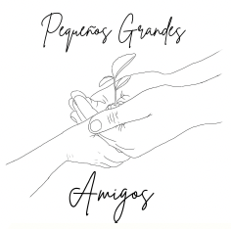
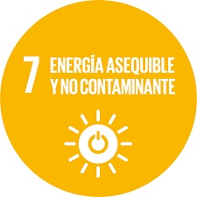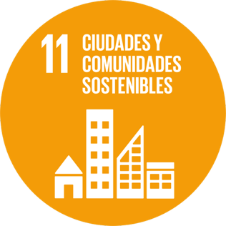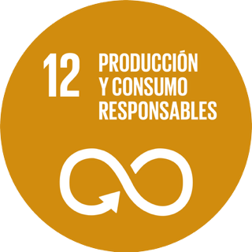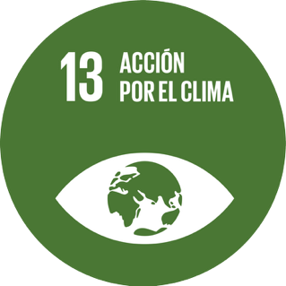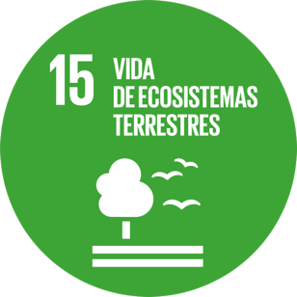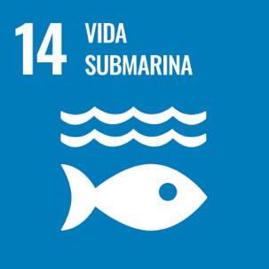

Context

- Country: Spain
- Full Name of the VET provider: IES Francisco de Orellana.
- Persons involved: clarify the quantity and quality of students involved, teachers involved and societal case provider.
22 persons have been involved in the project.
2 teachers and 17 students from VET study of Sociocultural Services.
3 representant from:
- C.E.I. La Escuelina: Early childhood education center for children aged 0–3 years.
- A.M. Virgen del Rosario: Association for the elderly focused on leisure, training, and the organization of events.
- Circular FAB: Open innovation space where participants design their own jobs, activities, projects, products, or services.

- Relevant Challenge Based Learning Scenarios (CBLSs): (include all the relevant CBLS your project is tackling).
Biodiversity, Environmental Awareness.
List of the 10 CBLSs
Sustainable transport | Protecting Biodiversity in Renewable Energy Power Plants
Green Construction | Circular Economy
Renewable energy | Water Scarcity
Environmental awareness | Water and Human Health
Short Food Supply Chain | Improving Water Quality

Developed Idea

- Title and short description of the idea: (if written, maximum 500 words)
Pequeños Grandes Amigos is an intergenerational project that connects infants, elderly people, and vocational students to promote environmental education and social inclusion. Through collaborative activities like building a vertical garden and an insect hotel, participants share traditional ecological knowledge and apply digital tools such as NFC codes and Arduino systems. The project fosters empathy, sustainability, and community engagement, making learning meaningful across generations.
- Start and end date of the prototyping process: 01/09/2024 – 30/06/2025
- Main objective of the initiative: To foster intergenerational collaboration that promotes environmental awareness, social inclusion, and digital literacy through shared learning experiences between young children, elderly participants, and vocational students.
- Local Community Impact: (if written, maximum 500 words)
The project strengthens community ties by connecting children, elderly residents, and vocational students through shared environmental and educational activities. It promotes inclusion, combats ageism, and encourages sustainable practices using local resources and knowledge. Elderly participants feel valued by sharing traditional wisdom, while children and students gain empathy and environmental awareness. Local institutions collaborate actively, creating a replicable model that benefits education, social cohesion, and ecological responsibility.
- Social Relevance and Innovation: (if written, maximum 500 words)
The project addresses key societal challenges such as ageism, environmental degradation, and digital exclusion by fostering meaningful collaboration between generations. Its innovative approach combines traditional ecological wisdom from older adults with modern digital tools like NFC codes and Arduino systems. By integrating these elements into early childhood education, the initiative creates inclusive, sustainable learning environments that strengthen community bonds and promote lifelong learning.
- Transferability and Openness: (if written, maximum 500 words)
The project is designed to be easily replicated in other early childhood education settings. Its methodology, combining traditional ecological knowledge with digital tools, is documented and shared through an open-access website. Activities are adaptable to different communities and age groups, promoting inclusive, sustainable education. Collaboration with local institutions ensures scalability and long-term impact.
- Adherence to the SDGs: (if written, maximum 500 words)
The project supports several UN Sustainable Development Goals, including SDG 4 (Quality Education), SDG 3 (Good Health and Well-being), SDG 11 (Sustainable Cities and Communities), and SDG 13 (Climate Action). It promotes inclusive, lifelong learning through intergenerational collaboration, enhances well-being across age groups, fosters ecological awareness, and encourages sustainable practices using digital and traditional knowledge.

Educational Process

- Description of the educational phases: (if written, maximum 500 words)
The project includes three educational phases: preparation, implementation, and reflection. In the preparatory phase, students and elderly participants co-design activities and materials. During implementation, children engage in short, meaningful sessions focused on environmental learning through storytelling, gardening, and interactive technologies. The reflection phase involves evaluating outcomes, sharing experiences, and publishing digital content to ensure long-term impact and replicability.
- Teaching methodologies adopted: (if written, maximum 500 words)
The project uses experiential, participatory, and inclusive methodologies. Learning is based on real-life interactions between generations, combining storytelling, hands-on environmental activities, and digital creation. It emphasizes active listening, cooperative learning, and emotional bonding. Sessions are short and adapted to the developmental needs of young children, while older participants contribute through oral traditions and ecological knowledge. Technology is integrated through NFC codes, Arduino systems, and digital media to enhance engagement and replicability.
- Involved educators/trainers: Who led or facilitated the activity? (Number, role)
The project was led by vocational education teachers from IES Francisco de Orellana, supported by students from the Early Childhood Education program. Key facilitation also came from Nacho Rodríguez Cid, technician at Circular FAB Trujillo, who guided the technological aspects. Educators coordinated with local nursery staff and senior association members to ensure inclusive participation and meaningful intergenerational learning.
- Student involvement level: Active co-design, passive participation, etc.
Students played an active role in co-designing and implementing the project. They collaborated with elderly participants to create educational materials, designed and built eco-technological tools like Arduino irrigation systems, and recorded digital content such as stories and refrains. Their involvement included planning, facilitating sessions with children, and coordinating with community partners, making them key drivers of the initiative.

Results

- Final product or solution developed: Explain the tangible result achieved (e.g. an app, a campaign etc.) – ((if written, maximum 500 words)
The project resulted in a vertical garden and an insect hotel co-created by children, elderly participants, and students. These spaces include NFC-coded educational content, Arduino-based smart irrigation systems, and digital storytelling materials. A dedicated website hosts all resources, making the project replicable and accessible. The tangible outcomes combine environmental education, intergenerational learning, and technological innovation.
- Intangible effect(s) of the final product or solution developed: (e.g. increased motivation, new competencies, new collaboration etc.) - (if written, maximum 500 words)
The project enhanced empathy, motivation, and collaboration across generations. Children developed social and communication skills, elderly participants felt valued and emotionally engaged, and students gained confidence, creativity, and digital competencies. It fostered a sense of belonging, strengthened community ties, and promoted environmental responsibility. Participants experienced meaningful learning and personal growth through shared experiences.
- Observed effects on students, teachers, and the educational context: (if written, maximum 500 words)
Students gained practical experience, improved digital and communication skills, and developed empathy through intergenerational collaboration. Teachers observed increased student motivation, creativity, and teamwork. The educational context became more inclusive and community-oriented, integrating real-world challenges like sustainability and social cohesion into early childhood education. The project fostered innovation and strengthened ties between schools and local institutions.
- Lessons learned / Recommendations: (if written, maximum 500 words)
Intergenerational collaboration enriches learning and strengthens community bonds. Adapting activities to participants’ needs—especially young children and elderly adults—is essential for meaningful engagement. Combining traditional knowledge with digital tools enhances motivation and creativity. Clear planning, inclusive participation, and strong local partnerships are key to success. We recommend documenting processes and sharing resources to support replication in other educational contexts.

