Template case study
  - WP n.2 – T2.7.1
Elga Contardi - EGInA

Template case study – [Title of the project]

Overall

- Short project summary: ((if written, maximum 500 words)
“We Are Water” is an educational initiative addressing water scarcity and food insecurity caused by climate change. Developed by students and teachers from health and agricultural vocational programs, the project promotes awareness of sustainable water use and introduces hydroponics as an eco-innovative solution. Hydroponic systems allow plants to grow without soil, using nutrient-rich water, which significantly reduces water consumption and environmental impact. The project includes workshops, research activities, and the creation of posters and presentations to engage the school community. Technological elements such as pH sensors and digital tools are integrated to monitor plant growth and optimize water use. The initiative encourages responsible consumption, highlights the concept of water footprint, and explores future improvements like solar energy and remote monitoring. It contributes to the Sustainable Development Goals and aims to be transferable to other educational contexts.
- Including logos or icons for visual navigation (e.g. SDG icons, VET symbols, ENNEPlus visual identity and EU visibility requirements).
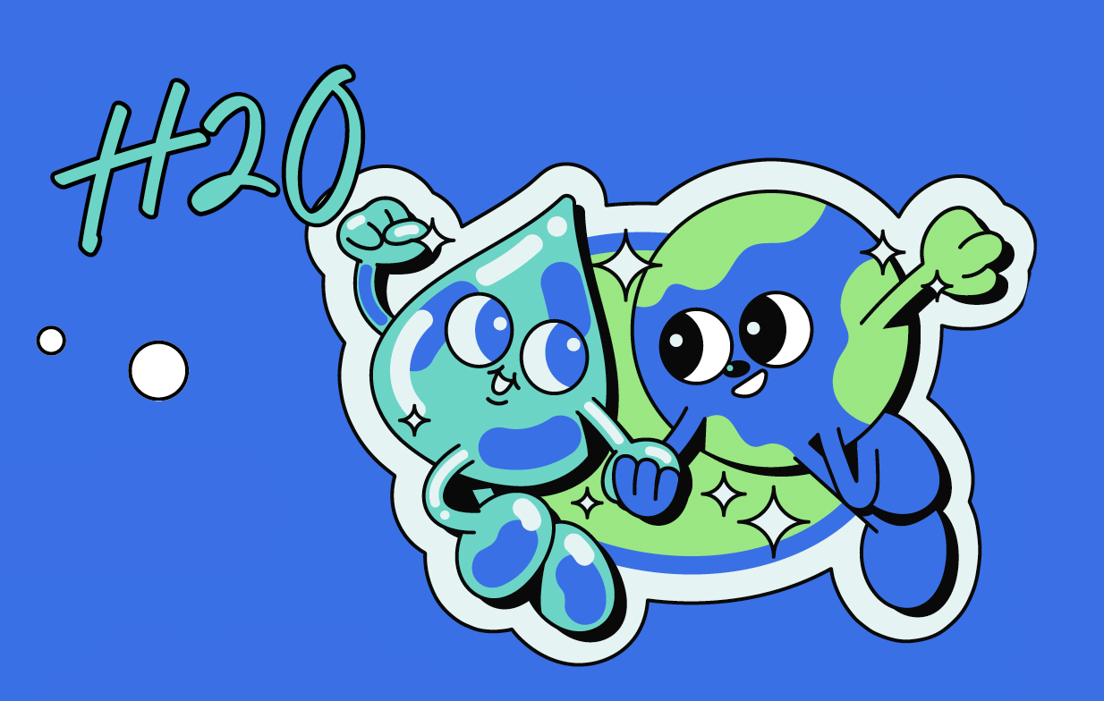
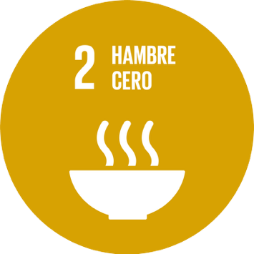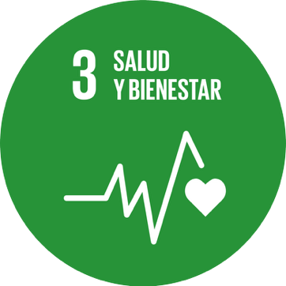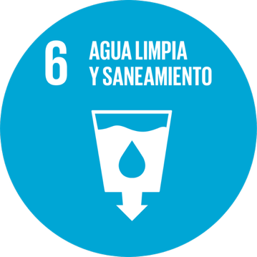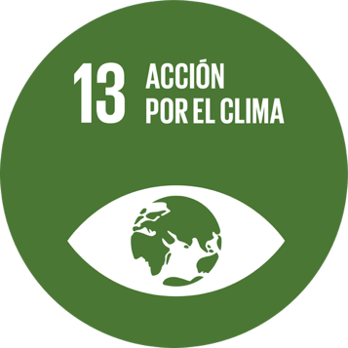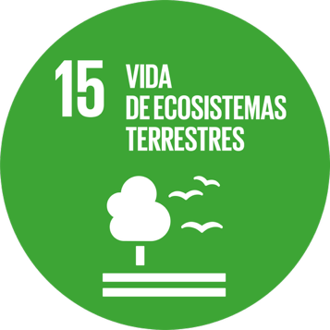

Context

- Country: Spain
- Full Name of the VET provider: IES Javier García Téllez
- Persons involved: clarify the quantity and quality of students involved, teachers involved and societal case provider.
34 persons have been involved in the project.
2 teachers and 30 students from Basic Vocational Training in Agro-gardening and Floral Arrangements, Agrarian sector and Higher Vocational Training in Health Documentation and Administration.
2 representants from:
- Postdoctoral Researcher at the Regional Government of Extremadura.
- Scientific and Technological Research Centre of Extremadura.
- Relevant Challenge Based Learning Scenarios (CBLSs): (include all the relevant CBLS your project is tackling).
Water & Human Health, Water Scarcity
List of the 10 CBLSs
Sustainable transport | Protecting Biodiversity in Renewable Energy Power Plants
Green Construction | Circular Economy
Renewable energy | Water Scarcity
Environmental awareness | Water and Human Health
Short Food Supply Chain | Improving Water Quality

Developed Idea

- Title and short description of the idea: (if written, maximum 500 words)
Title: We Are Water
This project addresses water scarcity and food insecurity through education and eco-innovation. Students explore sustainable water use and implement hydroponic systems to grow plants without soil, using less water and fewer chemicals. The initiative combines environmental awareness with digital tools like pH sensors, promoting responsible consumption and contributing to the Sustainable Development Goals. It encourages collaboration across disciplines and aims to be replicable in other educational settings.
- Start and end date of the prototyping process: 01/09/2024 – 30/06/2025
- Main objective of the initiative: To raise awareness about water scarcity and promote sustainable agricultural practices through the implementation of hydroponic systems in an educational setting.
- Local Community Impact: (if written, maximum 500 words)
The project raises awareness in the local community about water scarcity and sustainable food production. By involving students from health and agricultural programs, it promotes responsible water use and introduces hydroponic systems as practical solutions. Collaboration with local institutions, such as Finca La Orden (CICYTEX), strengthens ties between education and real-world environmental challenges. The initiative encourages behavioral change and offers a replicable model for other communities.
- Social Relevance and Innovation: (if written, maximum 500 words)
The project is socially relevant as it educates students and the local community about water scarcity and sustainable food production. It promotes responsible consumption and environmental awareness through hands-on learning. Its innovative aspect lies in integrating hydroponic systems with digital tools like pH sensors, enabling efficient water use and real-time monitoring. By combining education, technology, and sustainability, the initiative offers a forward-thinking approach to addressing global challenges.
- Transferability and Openness: (if written, maximum 500 words)
The project is designed to be easily replicated in other educational settings. It encourages collaboration between different vocational areas, such as agriculture, electronics, and renewable energy. Its modular structure and use of accessible technologies like hydroponics and sensors make it adaptable to various contexts. The initiative promotes openness by sharing results through social media and public events, inspiring other schools and communities to adopt sustainable practices.
- Adherence to the SDGs: (if written, maximum 500 words)
The project supports several Sustainable Development Goals (SDGs), especially SDG 6 (Clean Water and Sanitation), SDG 12 (Responsible Consumption and Production), and SDG 13 (Climate Action). By promoting water conservation, sustainable agriculture through hydroponics, and environmental awareness, it encourages responsible resource use and climate resilience. The educational approach empowers students to take action and fosters community engagement in sustainability efforts.

Educational Process

- Description of the educational phases: (if written, maximum 500 words)
The project follows a structured educational process: students begin by researching the water cycle and global water scarcity. They then explore water consumption in daily activities and industries, including agriculture and textiles. Through debates, poster creation, and data analysis, they raise awareness of water-related issues. Finally, they design and implement a hydroponic system, integrating digital tools like pH sensors. The phases combine theoretical learning, practical application, and creative communication to foster environmental responsibility and technological innovation.
- Teaching methodologies adopted: (if written, maximum 500 words)
The project uses active, student-centered methodologies, including inquiry-based learning, collaborative work, and hands-on experimentation. Students engage in research, debates, and creative tasks like poster design and presentations. Practical activities, such as building a hydroponic system and using digital sensors, foster experiential learning. The approach integrates environmental education with technological innovation, encouraging critical thinking, teamwork, and real-world problem solving.
- Involved educators/trainers: Who led or facilitated the activity? (Number, role)
The project was led and facilitated by teachers Sara López and Ana Isabel Galván. They guided students through each phase of the initiative, from research and awareness activities to the design and implementation of the hydroponic system. Their interdisciplinary approach involved students from health and agricultural vocational programs, fostering collaboration and hands-on learning.
- Student involvement level: Active co-design, passive participation, etc.
Students were actively involved in all phases of the project, from research and idea development to implementation and presentation. They co-designed the hydroponic system, conducted investigations, created visual materials, and practiced public speaking. Their participation was hands-on and collaborative, fostering ownership of the learning process and encouraging creativity, problem-solving, and teamwork.

Results

- Final product or solution developed: Explain the tangible result achieved (e.g. an app, a campaign etc.) – ((if written, maximum 500 words)
The tangible result of the project is a functional hydroponic system designed and built by students. It uses nutrient-rich water instead of soil, significantly reducing water consumption. The system includes digital tools such as pH sensors to monitor plant health and optimize growing conditions. Students also created educational materials, including posters and presentations, to raise awareness about water scarcity and sustainable agriculture within the school and local community.
- Intangible effect(s) of the final product or solution developed: (e.g. increased motivation, new competencies, new collaboration etc.) - (if written, maximum 500 words)
The project fostered increased student motivation, environmental awareness, and a sense of responsibility. It helped students develop new competencies in sustainability, teamwork, and digital literacy through hands-on activities and collaborative problem-solving. The initiative also encouraged interdisciplinary collaboration and strengthened connections between students, educators, and local institutions, creating a more engaged and informed learning community.
- Observed effects on students, teachers, and the educational context: (if written, maximum 500 words)
The project enhanced student engagement, motivation, and environmental awareness. Students developed new skills in sustainability, teamwork, and digital technology. Teachers observed increased collaboration across disciplines and a more dynamic, hands-on learning environment. The educational context benefited from stronger ties with local institutions and a shift toward project-based, interdisciplinary learning focused on real-world challenges.
- Lessons learned / Recommendations: (if written, maximum 500 words)
The project showed that combining sustainability with hands-on learning greatly increases student engagement. Clear planning and interdisciplinary collaboration were key to success. Using real-world data and digital tools helped students understand complex environmental issues. Future projects should continue integrating technology and encourage partnerships with local institutions. Simplifying technical concepts and fostering teamwork are essential for inclusive and impactful learning experiences.

