Case Study

ISTITUTO SUPERIORE ALFONSO CASANOVA DI NAPOLI

Case Study

The Environment is Our Home: The Earth is Our Home, Only Together Is It Possible!

Overall
- Short project summary:
The project “The Environment is Our Home: The Earth is Our Home, Only Together Is It Possible!” of the Alfonso Casanova Upper Secondary Institute of Naples aims to reduce water and energy waste in agricultural practices and to promote social inclusion.
The students created an eco-sustainable automated greenhouse using IoT systems and renewable energy sources (solar panels and a wind generator) to optimise resources. The greenhouse, which was also built using scrap materials, is an educational and inclusive Fab Lab where students with special needs can carry out hands-on gardening and technological learning activities. The project combines innovation, sustainability and inclusion, and contributes to the goals of the 2030 Agenda.
- Including logos or icons for visual navigation (e.g. SDG icons, VET symbols, ENNEPlus visual identity and EU visibility requirements):
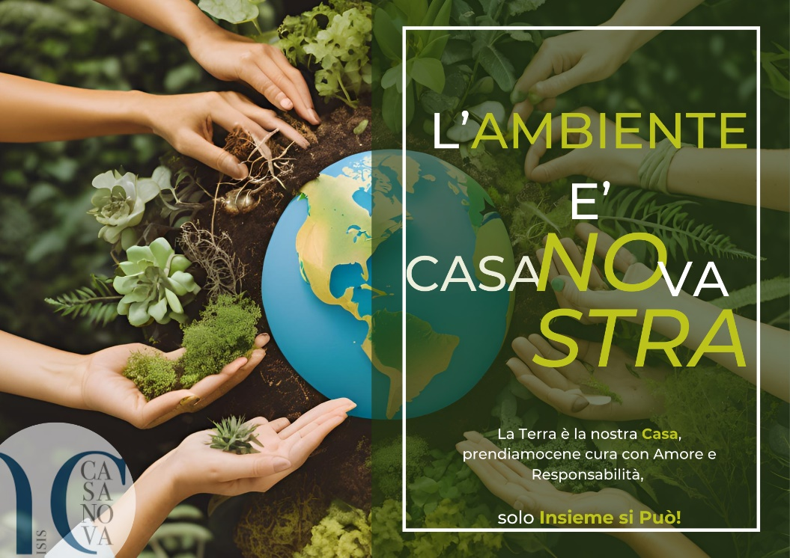


Context
- Country: Italy
- Name of the Institute: Alfonso Casanova Upper Secondary Institute of Naples
- People involved:
- 7 students from class 4, Mechatronics track
5 students from class 1, Vocational track in Maintenance and Technical Assistance
- 10 students from class 3, Vocational track in Maintenance and Technical Assistance
- 2 mechanics teachers
- 2 electronics and electrical engineering teachers
- 1 lab technician
- 1 teacher responsible for school inclusion
- Environmental macro-challenges (CBLS):
- CBLS no. 8 - Water Scarcity
- CBLS no. 7 - Circular Economy
- CBLS no. 3 - Renewable energy

Developed Idea
- Title and short description of the idea:
The project stems from the desire to respond to two concrete needs: reducing water and energy waste in cultivation and including students with special needs in laboratory activities.
The idea is simple and ambitious at the same time: to build an eco-sustainable automated greenhouse within the Institute, transforming it into a real laboratory for learning, innovation and social interaction, that is, a Fab Lab. The greenhouse, built using recycled materials, is equipped with a control system based on sensors and Arduino microcontrollers, able to autonomously regulate light, humidity, temperature and irrigation. As for energy, the focus is exclusively on renewable sources: photovoltaic

panels already installed at school and a vertical wind generator designed by the students themselves.
However, it is not just about technology: the greenhouse is also an inclusive place where students with special needs can engage in practical activities such as sowing and plant care, thus finding spaces for participation, personal growth and integration with their classmates.
In this way, the initiative has a dual value: on the one hand, it promotes sustainable practices related to recycling and to saving water and energy; on the other, it strengthens the values of solidarity and inclusion that the school aims to convey.
The project is not designed solely to function as an intelligent greenhouse, but as a living Fab Lab: a place where students can learn by doing, experimenting and working together, and where there is continuous innovation. The greenhouse also represents a concrete contribution to the Sustainable Development Goals, particularly those related to water, clean energy, sustainable communities and the fight against climate change.
- Start and end date of the prototyping process:
The prototyping process, understood as the transition from the initial project idea to the first functional implementation, began in February 2024. This preliminary phase was characterised by an intensive development cycle that made it possible to implement the prototype within a relatively short period of about two months.
It is essential to underline that the project, configured as a Fab Lab, intrinsically operates as an “open construction site” of ideas and continuous innovation. Consequently, although a starting point for implementation was defined, the activities of design, refinement and integration of new functionalities are still ongoing. The evolution of the project is therefore not bound to a definitive end date, but translates into a constant commitment to expanding and improving the laboratory itself and its potential.
- Main objective of the initiative:
The main objective of the initiative is to create an eco-sustainable and inclusive greenhouse that reduces water and energy waste and offers all students, particularly those with special needs, a place for hands-on learning.

- Local Community Impact:
The greenhouse also has a strong impact on the local community and represents a safe and stimulating environment, where students with special educational needs at the school – recognised, within the Eco-Digithon methodology, as an informal societal case provider, even though they do not form a formally established group – can actively participate in activities such as sowing, plant care and pruning.
- Social Relevance and Innovation:
The project addresses the need to create suitable places for practical activities for students with special needs. The greenhouse thus becomes a context in which everyone can participate in soil preparation, sowing and plant care. These experiences foster self-esteem, positive relationships and learning.
From the point of view of innovation, the value of the project lies in the integration between advanced technologies and sustainable practices. The eco-sustainable greenhouse uses IoT sensors, Arduino microcontrollers and automation systems to monitor and optimise water and energy consumption. Power from renewable sources, thanks to photovoltaic panels and a wind generator designed by the students, makes the structure energy self-sufficient and turns it into a cutting-edge educational laboratory.
This combination of social inclusion and technological innovation transforms the greenhouse into a living Fab Lab, where students not only learn technical skills that are useful in the labour market, but also contribute to producing value for the community.
- Transferability and Openness:
The model can be replicated in other institutes and local communities as a good practice of sustainability and inclusion.
- Adherence to the SDGs:
The project “The Environment is Our Home” fully fits into the framework of the United Nations 2030 Agenda, concretely addressing several global challenges through innovative and inclusive solutions.

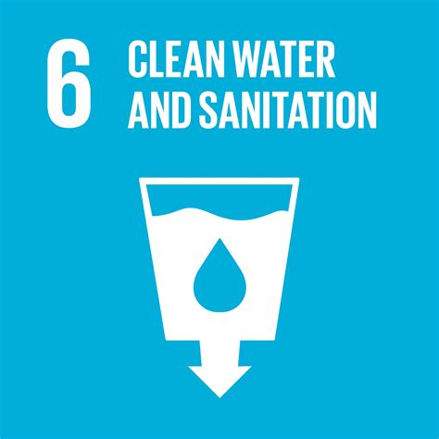
SDG 6 – Clean Water and Sanitation

The automated eco-sustainable greenhouse uses IoT sensors to monitor and optimise irrigation, reducing water waste. The focus on water efficiency responds to the problem of water scarcity, promoting sustainable water management practices even at local level.

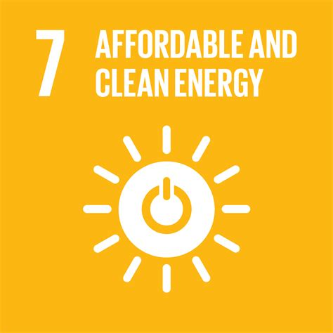
SDG 7 – Affordable and Clean Energy

The entire system is powered by renewable sources: photovoltaic panels and a vertical wind generator designed by the students. The choice to make the greenhouse energy self-sufficient is a practical example of how renewable energy can be integrated into everyday life and educational processes.

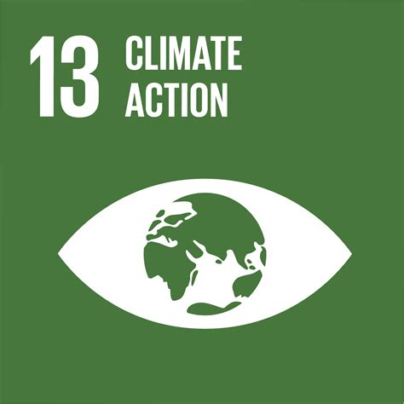
SDG 13 – Climate Action

The use of renewable energy and the reduction of waste make the project a small but significant contribution to the fight against climate change. The greenhouse becomes not only a technical laboratory, but also a symbol of collective commitment to reducing environmental impact.

Educational Process
- Description of the educational phases:
Phases | Main objectives | Activities carried out and results
Phase 1 – Needs Analysis and Awareness-raising | Frame the project within a real socio-environmental context and develop active citizenship. | Analysis of Scenario 8: Water Scarcity. Alignment with the Sustainable Development Goals (SDGs), in particular SDG 6, SDG 2 and SDG 11. Promotion of principles of civic engagement, solidarity and awareness of resources.
Phase 2 – Technical Design and Planning | Define the architecture of the smart greenhouse, its energy autonomy and the IoT control system. | Structural design using eco-sustainable materials and techniques. Planning of the electrical system and electronic systems. Selection of microcontrollers. Design of the VAWT vertical-axis wind generator.
Phase 3 – Practical Workshops and Prototyping | Physically build the eco-sustainable greenhouse and program the automation for self-management. | Construction of the greenhouse using scrap materials. Installation and programming of IoT systems. Construction of the VAWT wind generator
Phase 4 – Inclusive Activities and Collaboration with the Territory | Promote socio-collaborative inclusion and build alliances to disseminate the model. | Activation of the greenhouse for extra-curricular activities aimed at students with disabilities enrolled at the Institute.

- Teaching Methodologies Adopted:
Metodologia Didattica | Role of the teacher | Students’ actions | Expected product/result
Problem-Based Learning (PBL) | Guides the analysis of the context (Scenario 8: Water Scarcity) and facilitates the link with the Sustainable Development Goals (SDGs). | Analyse data, identify critical issues (water and energy waste) and propose sustainable and innovative solutions. | Context analysis document and initial concept design for the automated greenhouse.
Team-Based Learning & Didattica Laboratoriale | Supervises specialist teams (Mechanical–Mechatronics and Electrical–Electronics) and provides tools and technical specifications. | Design subsystems and work on hardware platforms (e.g. Arduino). | Design outputs (electrical diagrams, technical drawings), list of components and system programming code.
Learning by Doing | Provides the theoretical framework and scrap materials; delegates practical implementation. | Physically build the greenhouse, install and calibrate sensors and the VAWT wind generator. | Prototype of the eco-sustainable automated greenhouse, energy self-sufficient.
Inclusive Teaching & Peer Tutoring | Assigns targeted tasks and supervises interaction among students (Inclusion Team). | Students with disabilities carry out concrete activities (sowing, cuttings, pruning) with support from peers. | Improved self-esteem and practical skills; promotion of socio-collaborative inclusion.

- Involved educators/trainers:
The teams directly involved in implementing the project are:
- 2 teachers for the design, construction and testing of the greenhouse from both a structural and energy point of view, using eco-sustainable materials and techniques;
- 2 teachers for the general design and configuration of the electrical systems and the reference characteristics of the electronic control systems to be developed and used.

- Student involvement level: Active co-design, passive participation, etc:
The students have shown notable sensitivity to the crucial issues addressed, such as energy sustainability, water scarcity (Scenario 8) and social inclusion. Their contribution was not limited to carrying out technical instructions, but extended to generating further ideas and conclusions, significantly enriching the conceptual framework of the project.
This approach promoted the principle of valuing personal abilities and a focus on continuous improvement. A particularly significant result emerged during the presentation of the work at the Eco Digithon in Foligno, Italy. The student team involved had an intensive experience of teamwork, engaging with an external reality different from their usual context. On that occasion, their level of preparation and the quality of their presentation contributed to gaining considerable respect and recognition in the overall evaluation.
This external success strengthened their sense of belonging to the group and significantly boosted their individual self-esteem, further consolidating team cohesion.

Results
- Final product or solution developed: Explain the tangible result achieved (e.g. an app, a campaign etc.):
The physical structure of the greenhouse is fully operational for cultivation activities. At present, the digital and home automation component is being refined and completed, with students focusing on improving the control algorithms to optimise the efficiency of managing environmental parameters.
The real design challenge and the most significant technical achievement of the project lie in the creation of the greenhouse’s energy autonomy system, particularly the Vertical Axis Wind Turbine (VAWT). The VAWT was entirely designed, calculated, tested and built by the student teams, representing a complex exercise in mechatronic engineering. The design was inspired by the model of Persian windmills, demonstrating the ability to apply historical principles to contemporary technological solutions.

