Case study

I.P.I.A. “Galileo Ferraris” – Iglesias

Case Study

Automation Prototype of an Automatic Gate

Overall
- Short project summary:
The project “Automation Prototype of an Automatic Gate” of I.P.I.A. Galileo Ferraris in Iglesias consists in the construction of an automatic gate entirely built with recycled materials, combining mechanics, electronics and safety through hard-wired logic without software programming.
The students transformed waste and discarded components into a functional, safe and efficient system, reducing environmental impact and promoting the circular economy. The project has a strong educational and social value, engaging the community of Siliqua in raising awareness that what is usually defined as waste can actually be a resource.
Prototyping was carried out in the school laboratories, with the support of teachers and local experts, enhancing innovation, sustainability and practical skills.
- Including logos or icons for visual navigation (e.g. SDG icons, VET symbols, ENNEPlus visual identity and EU visibility requirements)


Context
- Country: Italia
- Name of the Institute: I.P.I.A. “Galileo Ferraris” – Iglesias
- People involved:
- 23 students from two third-year classes, Maintenance and Technical Assistance track
- 2 laboratory teachers, Electrical and Electronic track
- 1 laboratory teacher, Mechanics and Mechatronics track
- 1 teacher of Electrical and Electronic subjects
- Mayor of Siliqua
- ALIGÒ (Ecological Services) ALIGO' (Servizi Ecologici)
- Selected environmental macro-challenges:
- CBLS n. 8 - Circular Economy
- CBLS n. 4 - Environmental awareness
- CBLS n. 2 – Green Construction

Developed Idea
- Title and short description of the idea
The project stems from the need to experiment with and promote innovation and environmental sustainability within the MAT (Mechanics and Technical Assistance) laboratories of I.P.I.A. Galileo Ferraris in Iglesias.
The students took on the challenge of designing and building an automatic gate using scrap materials and, subsequently, of raising awareness in the Municipality of Siliqua about the importance of adopting a sustainable vision, in which what is normally considered waste can become an opportunity for creativity and innovation.
The underlying idea is simple yet innovative: to transform discarded components, such as old PCs, kitchen extractor hoods, plexiglass used during Covid, car parts and ferrous materials, into a functional and safe automation system. The control unit does not require complex software, but is built using hard-wired logic, directly connecting sensors and motor. Photocells and limit switches ensure safe and precise movement, while the reuse of materials reduces environmental impact and production costs, concretely promoting the circular economy.

- Start and end date of the prototyping process:
The project began in June 2023 as a design initiative, but its full implementation took almost a year and a half. Work started in October 2023 and was completed in May 2025.
The collection and sourcing of waste materials in all areas, both electrical and electronic, involved students in meticulous work, characterised by great patience and precision. The mechanical part of the construction proved particularly demanding: in addition to recycling materials, didactic practices linked to the third-year curriculum were applied, such as welding, riveting, galvanising and similar operations.
Between the end of 2024 and throughout 2025, students focused on the electrical and electronic components of the project, also devoting themselves to the finishing stages.

- Local Community Impact:
The project Automation Prototype of an Automatic Gate has generated a significant environmental impact. The gate was built mainly with recovered materials obtained through urban mining, that is, by salvaging components from discarded items such as old PCs, electronic components, kitchen extractor hoods, plexiglass and mechanical parts from cars. This choice made it possible to promote the circular economy, transforming objects destined for disposal into useful and functional resources.
The social impact materialised through cooperation with the Municipality of Siliqua, which recognised in the project a concrete response to waste management. Within this context, a training day was organised with the municipality’s sanitation workers, to show how waste can also represent a valuable resource.

- Social Relevance and Innovation:
The project Automation Prototype of an Automatic Gate stands out for its social relevance and innovation. Waste management is a global challenge and, in contexts such as Sardinia, characterised by limited natural resources, it is crucial to reduce waste and enhance materials already present in the territory.

The project directly addresses this need by promoting the reuse of objects and materials considered scraps or waste, giving them new life in the form of functional components of the automatic gate. Innovation lies not only in technology, but also in the creativity with which students used the materials: the gate grilles were made using a discarded kitchen hood; the cap of a detergent bottle was turned into the gate light; discarded electronic and mechanical components were integrated into the automation system.
- Transferability and Openness:
The project stands out for its high accessibility and replicability. Based exclusively on recovered materials and on simple hard-wired logic, the prototype is within the reach of schools, communities and small local authorities without substantial economic or technological resources.
The educational approach combines reuse and reverse engineering, ensuring low costs, environmental sustainability and a concrete training path for students.
In terms of transferability, the project can be used as a prototype for further educational experiments in school laboratories. Although it is not possible to develop it beyond the prototype stage due to regulatory constraints, the most important replicable aspect remains the core idea: transforming scrap materials into useful resources.
This concept can be adopted in other educational contexts, stimulating creativity, innovation and a culture of sustainability and circular economy.
- Adherence to the SDGs:
The project Automation Prototype of an Automatic Gate fits perfectly into the objectives of the 2030 Agenda, demonstrating how a school activity can generate value for the community, the environment and future generations.
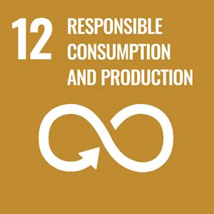
SDG 12 – Responsible Consumption and Production.
By recovering components from old computers, cars and discarded equipment, the project promotes the circular economy and shows how it is possible to create innovation while reducing waste and environmental costs.

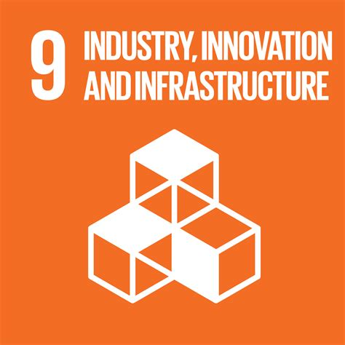
SDG 9 – Industry, Innovation and Infrastructure
The project shows how automation can be rethought using simple, safe and sustainable solutions. The use of hard-wired logic, without complex software, demonstrates that innovation can be within everyone’s reach, with low costs and maximum replicability.

Educational Process
Description of the Training Phases:
- Needs analysis and awareness-raising
- Initial lessons dedicated to the importance of recycling and sustainability.
- Theoretical insights into circular economy and responsible resource management.
- Technical design and planning
- Project design using CAD.
- Identification of the necessary materials.
- Consultations with technicians and local companies specialised in recycling (e.g. ALIGÒ) for the procurement and reuse of materials.
- Practical workshops and prototyping
- Construction activities and reuse of ferrous materials (e.g. old bars, kitchen hood), assembled using MIG welding.
- Turning of the shaft of the toothed wheel.
- Construction of a power supply unit using old PC components.
- Recovery of an old windscreen wiper motor as the main motor for the automation.
- Reuse of discarded cabling and electrical panels for assembling circuits and connecting photocells from a decommissioned gate.
- Inclusive activities and collaboration with the territory
- Dissemination of the project and its results in collaboration with the municipal administration of Siliqua.

- Teaching methodologies adopted:
The teaching methodologies adopted in the project prioritised laboratory-based teaching, allowing students to experience in a practical and concrete way all the stages of design and construction of the automatic gate. In the laboratories, circle time was often used, during which students could share opinions and ideas, actively collaborating in the search for solutions and in carrying out the practices needed to achieve the objectives. For the theoretical part, participatory lessons were used, encouraging the direct involvement of students in constructing knowledge. The approach was also strongly interdisciplinary, combining the skills from mechanics laboratories with those from electrical and electronic laboratories, offering students a complete and integrated view of the design process.
- Educators/trainers involved: Who led or facilitated the activity?
1 teacher of Technological and Mechanical Laboratories
1 teacher of Electronics and Applied Electronic Technologies (TEEA)
2 teachers of Technological Electrical Laboratories

- Student involvement level: Active co-design, passive participation, etc.
Through co-design, we created a learning environment that actively involved all stakeholders: students, teachers, families and, finally, the community of Siliqua.

Results

- Final product or solution developed: Explain the tangible result achieved (e.g. an app, a campaign etc.)
The final product is a prototype of an automatic gate with hard-wired automation. It is a product aligned with the study track, which represents a starting point for the development of any kind of further application.

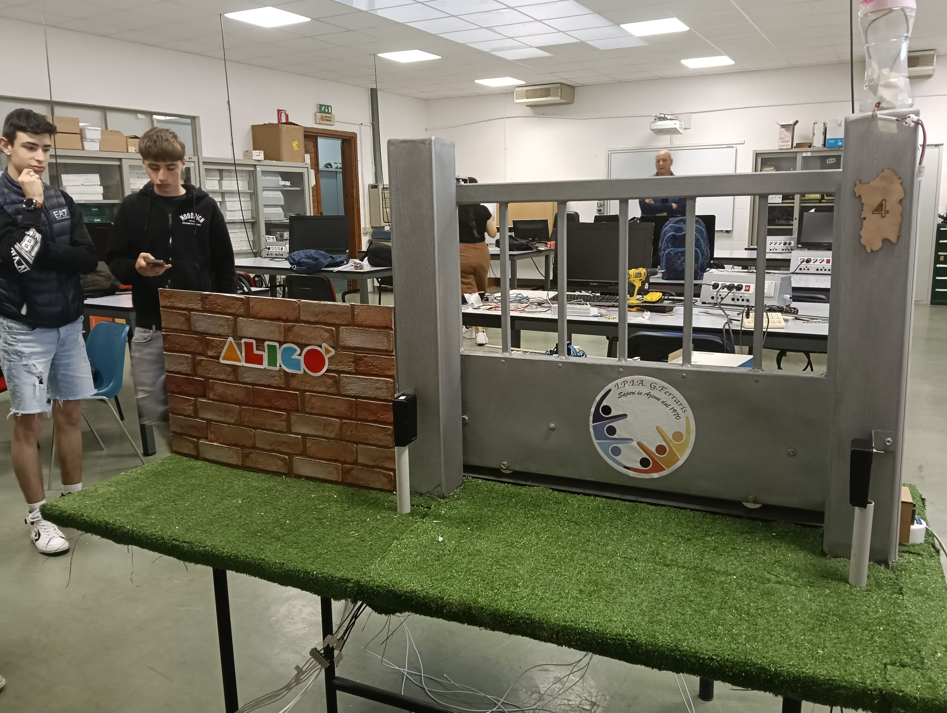

- Effects observed on students, teachers and the educational environment
The project prompted the school to actively reflect on the theme of recycling, considering it both as a resource and as a possible solution to problems related to waste. Students changed their approach to scrap materials, developing an awareness that
every object can be transformed into a resource and reused, concretely applying the principles of the circular economy. Other teachers, although not directly involved in the competition team, also showed interest in the initiative and appreciated the idea developed, integrating elements of recycling into other teaching units. Among these, for example, is the construction of a small traffic light system using recycled materials and with the support of Arduino.

